**OSG Compass Instructions**

Contents

Articles 2

How to Publish an Article – Basic Steps 2

How to Publish an Article – Detailed Instructions 2

Embedding Inline Photos in an Article 5

Emphasizing a Quote in an Article 6

Shortcodes to Move Ad Placements in Articles 7

Dynamic Gallery 10

Shortcode to Move Dynamic Gallery in Articles 10

Tagging a Photo so It’s Not Included in the Dynamic Gallery 10

Insert “Buy Now” Button 10

How to add Sponsor Logo to an Article (Native Content) 11

Videos 12

How to Publish a Video – Basic Steps 12

How to Publish a Video – Detailed Instructions 12

Video Shortcodes and Iframe Codes 13

Video Shortcodes: 14

Video Iframe Codes: 14

YouTube Embed Code: 15

Homepage Updates 15

Homepage Related Videos 15

Homepage Related Articles 16

Featuring an Article on the Homepage 17

Listing Page Updates 17

Featuring an Article on Top of a Listing Page 17

How to add a Redirect 17

How to create a “War Mode” promo 19

Event Pages (SHOT Show, ATA Show, ICAST) 21

SHOT Show 21

Creating a Photo Gallery 21

Common HTML 22

# Articles

## How to Publish an Article – Basic Steps

1. Create Images and Upload to FTP
2. Create “Media - Photo” Item in Compass
3. Create “Pages - Articles” Item in Compass

## How to Publish an Article – Detailed Instructions

**Step 1: Create Images and Upload to FTP (/osg_content)**

1. Create 2 sizes for the Hero photo:

**840x560** (Hero Image URL; filename: article-name-840x560.jpg)  
**420x280** (Large Thumbnail Image URL; filename: article-name-420x280.jpg)

And 1 size for each inline photo:

**840x560** or **840x316** (rifle inline photo)

Inline photos must be 840 width, preferably 840x560. Maximum height for portrait photos is 840x960. If a photo is resized any taller, it will push the photo gallery arrows down the page (below the fold).

1. Upload images to the FTP. Your remote site should say /osg_content/. Below are all of the magazine folders. This is where all images on the sites live. Click the site you are working on, then drag the sized photos into the /content/photos folder.

FTP folder names for magazine sites:

Bowhunter: bowhunter

Firearms News: firearmsnews

Florida Sportsman: floridasportsman

Fly Fisherman: flyfisherman

Game and Fish: gameandfishing

Gun Dog: gundog

Guns and Ammo: gunsandammo

Handguns: handgunsmag

In-Fisherman: infisherman

North American Whitetail: northamericanwhitetail

Petersen’s Bowhunting: bowhuntingmag

Petersen’s Hunting: petersenshunting

Rifle Shooter: rifleshooter

Shooting Times: shootingtimes

Wildfowl: wildfowl

1. Copy and paste the photo URLs from the FTP (right click, copy URLS to clipboard, paste in word doc or notepad). The URLs will look something like this:

ftp://jessyca.sortillon@ftp.winnercomm.com/osg_content/gameandfishing/content/photos/SmokerHero840.jpg

Before you paste the URLs into Compass (in Step 2), replace “ftp://jessyca.sortillon@ftp.winnercomm.com/osg_content ” with “//content.osgnetworks.tv/” in each URL.

Like this:  
//content.osgnetworks.tv/gameandfishing/content/photos/SmokerHero840.jpg

Note: Old images will keep the same name and should work. New images and articles need to be uploaded to the correct FTP folder and the path also entered into Media-Photo in Compass.

**Step 2: Create “Media - Photo” Item in Compass**

1. Select **Media - Photo**.
2. Click **Add** to create new photo item.
3. **Website** – select website of magazine you want the article to go to
4. **CMS Name**, **Meta Page title**, **Link Headline** – enter photo title (use same title as article)
5. **CMS Description**, **Meta Description**, **Teaser**, **Story** – enter photo caption/credit (if any). Links can only be entered in the Story field. Note: The “**Story**” displays directly below the photo. Only fill this in if there is a caption/credit for the photo. If the photo has no caption/credit, leave the Story field blank.
6. **Keywords** – enter article title and any other applicable keywords, like the magazine name and author
7. Enter the photo URLs in the following three fields:  
   Hero Image URL – 840x560  
   Large Thumbnail Image URL – 840x560 (thumbnails on HP)

Small Thumbnail Image URL – 420x280 (thumbnails on listing pages)

1. **Is_Active** – check to activate photo
2. **StartPublishDate** – enter start date
3. **EndPublishDate**– enter date with year 2100 so it doesn’t expire. Example: 12/1/2100
4. Click **Submit**.

**Step 3: Create “Pages - Articles” Item in Compass**

1. Select **Pages - Articles**
2. Click **Add**
3. **Website** – select website article will be published on.
4. **CMS Name, Display Name / Headline**, **Page title**, **Link Headline** – enter title of article
   1. CMS NAME – only shown in Compass
   2. Display Name / Headline – main title on article page (h1 tag)
   3. Page title – meta title tag in source code
   4. Link Headline – title of article on HP thumbnail, Listing page thumbnail, and related article in left rail
5. **CMS Description**, **Meta Description**, **Teaser** – enter teaser.
   1. CMS Description – only shown in Compass
   2. Meta Description – meta description tag in source code
   3. Teaser – displays below each article thumbnail on the HP and Listing pages
6. **Story** – enter story; insert inline photos as needed.

Notes:

- Use the link buttons to insert or remove links

 - Use Normal and HTML buttons on bottom left to flip back and forth from preview and html mode.

1. **Keywords** – enter title of article and any applicable keywords.

Example: 5 Beast Concealed Carry Drills, self defense, shooting tips

1. **Parent Website / Parent Website URL –** SKIP if this is a regular article. If you are teasing to an article on another OSG site, select the Parent Website and enter the URL where to link to.
2. **Template Filename** – SKIP – this is currently not used.
3. **Sub title** – enter article subtitle
4. **Friendly URL String** – manually enter the friendly URL or click the blue gear icon to automatically generate the friendly URL.

If you choose to manually enter the friendly URL, remember to use hyphens in place of spaces, use all lowercase letters, and not include special characters. There should be no spaces in friendly URLs.

Friendly URL String example: 5-best-concealed-carry-drills

This is how it will look in the full article URL: [www.handgunsmag.com/editorial/5-best-concealed-carry-drills/138078](http://www.handgunsmag.com/editorial/5-best-concealed-carry-drills/138078)

1. **Posted Date to Display** – enter publish date to display on article (this is not the date the article will go live on site)
2. **Display Posted Date** – check box to display Posted Date on the page. If not checked, Posted Date is hidden. (Check this box to hide date on Recipes.)
3. **Byline** – enter author name (If you need to include quotes, use single quotes). Note: If you’re doing something like: Guns & Ammo Digital Staff, Game & Fish Digital Staff, just drop the “Digital.” Going forward, they will read: Guns & Ammo Staff, Game & Fish Staff
4. **Website Content Source** – SKIP (This is for future use when we migrate DeerWeek and those types of sites in.)
5. **Article Media Type** – select Website - Article (Ex. Handguns - Article)
6. **Article Content Type** and **Article Sub Content Type** – select the appropriate content types (category and subcategory)
7. **Is_Active** – check to activate article
8. **StartPublishDate** – enter start date (when article will be active)
9. **EndPublishDate**– enter end date (If no end date, enter date with year 2100 so it doesn’t expire) Example: 12/1/2100)
10. Click **Submit**.
11. Select and edit article item again – this time to add related items.
12. Add the following related items:  
    -Related Hero_Photos (required – this is the lead photo on the page)  
    -Related Videos (if applicable)  
    -Related Photo_Galleries (if applicable)

-Related Secondary: Content Types and Related Secondary: Sub Content Types

1. Click **Submit**.
2. Preview article to verify everything looks good:

www.handgunsmag.com/editorial/[friendly-url-string]/[ARTICLE ID]  
Example: [www.handgunsmag.com/editorial/5-best-concealed-carry-drills/138078](http://www.handgunsmag.com/editorial/5-best-concealed-carry-drills/138078)

## Embedding Inline Photos in an Article

Use the following html codes to embed inline photos into articles (replacing red text as needed). Copy and paste the HTML into Notepad first, then copy and paste from there into Compass.

**Inline Image with Caption:**

<figure class="story-image no-margin-top no-margin-bottom">

<img src="//content.osgnetworks.tv/northamericanwhitetail/content/photos/venison-pot-pie-recipe-770x513.jpg" alt="Venison Pot Pie" width="770" />

<figcaption>Caption/Credit</figcaption>

</figure>

**Inline Image without Caption:**

<figure class="story-image no-margin-top no-margin-bottom">

<img src="//content.osgnetworks.tv/northamericanwhitetail/content/photos/NAWRut-Sign.jpg" alt="NAWRut-Sign" width="840" />

</figure>

**Clickable Inline Image with Caption:**

<figure class="story-image no-margin-top no-margin-bottom">

<a href="http://www.northamericanwhitetail.com/editorial/venison-pot-pie-recipe/262064"><img src="//content.osgnetworks.tv/northamericanwhitetail/content/photos/venison-pot-pie-recipe-770x513.jpg" alt="Venison Pot Pie" width="840" /></a>

<figcaption>Caption/Credit</figcaption>

</figure>

## Emphasizing a Quote in an Article

Quoted article example: <http://www.handgunsmag.com/editorial/sample-pull-quote-gallery/245844>

To emphasize a quote within an article, use this HTML:

<blockquote>Enter Quote Text Here</blockquote>

## Shortcodes to Move Ad Placements in Articles

If you need to move ads in a new article (or when reworking an older article), you can use the shortcodes below. Simply embed the appropriate shortcode in the html of the story where you want the ad to display.

**Shortcodes to use to move ads:**

[teads]  
[revealad]   
[adpos_rightC]

[adpos_rightD]

**Where each ad automatically displays:**

Teads – after 4th <P>

Reveal – after 5th <P>

Right C (1st Rectangle 300x250 or “Video That May Interest You” video player) – after 9th <P>

Right D (2nd Rectangle 300x250)  – after 12th <P>

**Examples of what each ad looks like:**

[teads]

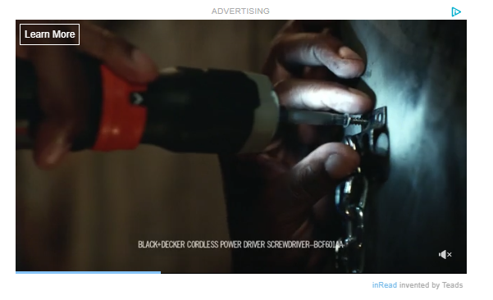

[revealad]

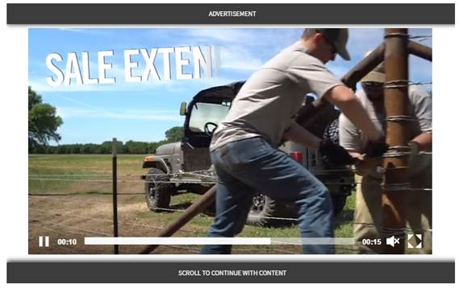

[adpos_rightC]

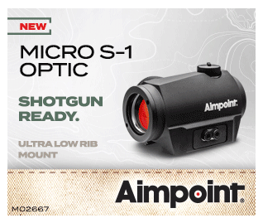

OR

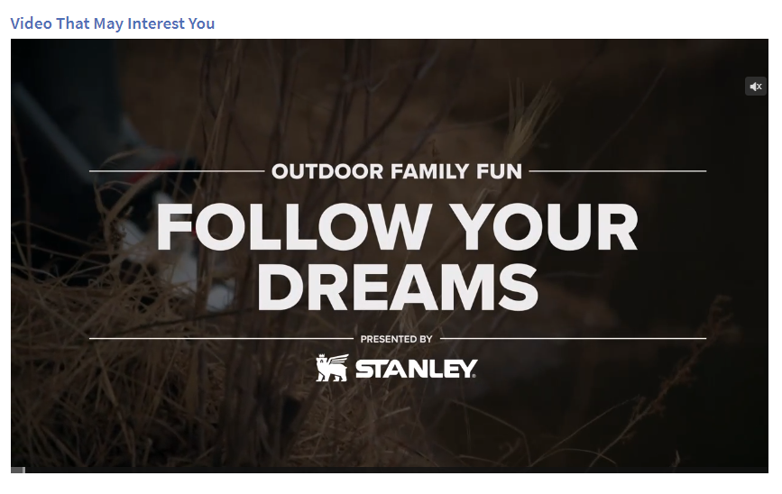

[adpos_rightD]



## Dynamic Gallery

### Shortcode to Move Dynamic Gallery in Articles

If you need to move the dynamic photo gallery in an article, use the shortcode below.

**Shortcode:**

<div id="dynamic_gallery"></div>

For example, this is what the dynamic gallery looks like:

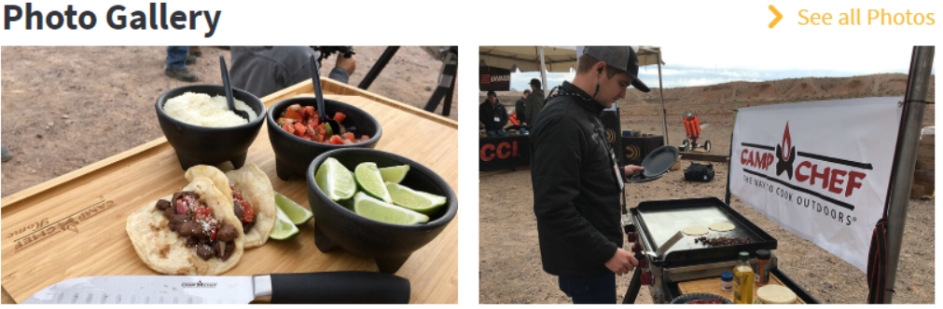

### Tagging a Photo so It’s Not Included in the Dynamic Gallery

For existing photo embeds you can add the class “no-gallery” to the <img /> tag and it won’t be included.

Example:

<figure class="story-image no-margin-top no-margin-bottom"><img class="no-gallery" src="//content.osgnetworks.tv/infisherman/content/photos/pickled-fish-recipe-770x513.jpg" alt="Pickled Fish Recipe" width="840" />

<figcaption>With this recipe, you'll have tasty pickled fish ready in seven days. (In-fisherman.com photo)</figcaption>

</figure>

## Insert “Buy Now” Button

For a standard button without the caret, you can use the class “btn” to add the rounded corner and background color. This would be formatted like:

<p><a href="/link/" class="btn">Button Text</a></p>



If you want the caret in it as well, you’d add a span with class icon-arrow-right inside the text area like:

<p><a href="/link/" class="btn">Button Text <span class="icon-arrow-right"></span></a></p>



## How to add Sponsor Logo to an Article (Native Content)

**Step 1: Size image and upload to FTP**

1. Size image to 240x150 (Logo should have a white background; Dimensions may vary slightly depending on logo size, but try to keep to 240x150, 300 width max)
2. Name image file. Example: pnuma-outdoors.jpg
3. Upload image to the /osg_content/sponsor-logos-magazines folder on FTP.
4. Save image URL. Example: //content.osgnetworks.tv/sponsor-logos-magazines/pnuma-outdoors.jpg

**Step 2: Create Sponsor Item in Compass**

Prior to creating a sponsor, always check to make sure the sponsor doesn’t already exist so we’re not duplicating items in Compass.

1. Select **Sponsor.**
2. Click **Add.**
3. **Keywords**, **CMS Name**, **Sponsor Name:** Enter sponsor name. “Sponsor Name” will show up on the site.
4. **ImageURL Sm**: Enter image URL. Ex: //content.osgnetworks.tv/sponsor-logos-magazines/pnuma-outdoors.jpg
5. **Link URL:** Enter click-through URL. Ex: <https://www.pnumaoutdoors.com/>
6. **Link Target**: Select “New Window or Tab”
7. Check the **Is Active** box.
8. **Start Publish Date**: Enter start date.
9. **End Publish Date**: Enter end date in the future so the sponsor does not expire. Ex: 12/1/2100
10. **Submit**.

**Step 3: Edit Article, enter Camp Id, and relate sponsor under “Related Sponsor”**

The logo will appear on the top left of the article, under “Sponsored By”. Example below.

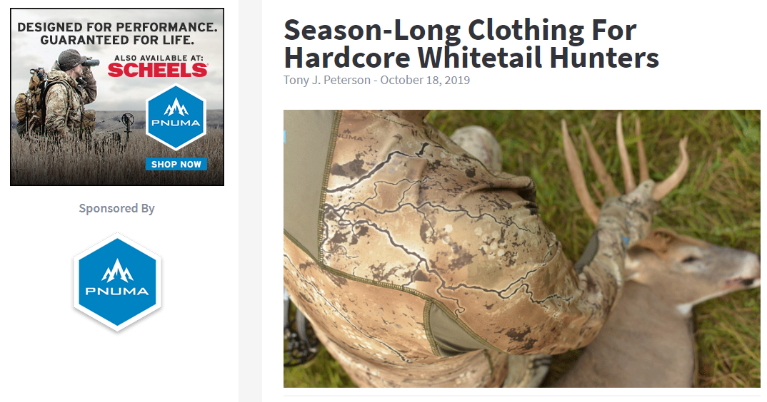

# Videos

There are two ways to add a video to an article:

**Method 1** – Embed the video within an article’s story using a shortcode (or iframe if embedding multiple videos on one page). Do this when you want to embed one or more videos inline throughout a story, or when you don’t want the video to replace the Hero photo at the top of the page.

**Method 2** – Relate a Video Item to an article so it displays at the top of the page. To do this, create an article as usual, but select Article Media Type “Video” and relate the Video item.

Example: <http://in-fisherman.com/editorial/mounting-reel-seat/154423>

## How to Publish a Video – Basic Steps

1. Send video file to [Brady](mailto:Braden.Lidard@OutdoorSG.com) to upload – SKIP this step if video is already in Compass.
2. Edit “Video” item in Compass as needed
3. Create “Pages - Articles” Item in Compass and Embed video into Story using iframe code **OR** Relate Video item to article

## How to Publish a Video – Detailed Instructions

**Step 1: Send video file to Marshal to upload** – SKIP this step if video is already in Compass.

1. Send video file to [Marshal.Halloway@OutdoorSG.com](mailto:Marshal.Halloway@OutdoorSG.com). He will upload the file to the temp folder on the new OSG ftp (/367555/OutdoorSportsmanGroup/temp) and move it to the “watch” folder for transcoding to occur. Once the video has transcoded, it will populate in Compass under “Videos”. When the video is ready, Marshal will send you the Video Id in Compass.

**Step 2: Edit “Video” Item in Compass** (only edit if needed; Marshal’s team usually makes these edits when uploading the video)

Edit the following video info if needed. Title and descriptions are for the video within the video player, NOT what shows up on the article page. Video item must be active to publish.

1. Select **Video**.
2. Click **Edit.**
3. Select correct Video item; click **Edit**.
4. **CMS Name**,**Display Name / Headline**, **Meta Page title**, **Link Headline** – enter video title
5. **CMS Description**, **Meta Description**, **Teaser**, **Story** – enter video teaser/description
6. **Keywords** – add any applicable keywords
7. Scroll down to **Is_Active** and check the box to activate video.
8. **StartPublishDate** – enter start date
9. **EndPublishDate**– enter date with year 2100 so it doesn’t expire. Example: 12/1/2100
10. Click **Submit**.

**Step 3, Method 1: Create “Pages - Articles” Item in Compass *with Embedded Video***

(SKIP to Step 3, Method 2 to relate a video to the top of an article page)

1. Create “Pages - Articles” Item in Compass as usual. Only change will be in the Story.
2. **Story** – add Story HTML as usual and embed video using the appropriate video shortcode or iframe code.
3. Click **Submit**.
4. Select and edit article item again to add Hero photo as usual.
5. Click **Submit**.
6. Preview article to verify everything looks good. Example: <http://www.flyfisherman.com/editorial/video-test/327087>

**Step 3, Method 2: Create “Pages - Articles” Item in Compass *with Related Video***

1. Create “Pages - Articles” Item in Compass as usual (instructions in this doc). Only change will be the Article Media Type and Related Video.
2. **Article Media Type** – select **Website - Video** (Ex. Fly Fisherman - Video).
3. Click **Submit**.
4. Select and edit article item again to relate video.
5. Scroll down to **Related Videos** and add video.
6. Click **Submit**.
7. Preview article to verify everything looks good. Video player should display at the top of the page. Example: <http://www.flyfisherman.com/editorial/video-test/327087>

## Video Shortcodes and Iframe Codes

Each article can have either 1 video shortcode or one related video for the hero spot. Putting more than one video in an article requires the use of an iframe.

If adding **one video** to an article, use a video shortcode to embed it (or relate the video to the article so it plays in the hero spot).

If adding **multiple videos**, use iframe codes for the videos. Set the first video to autoplay; turn autoplay off remaining videos in the article.

### Video Shortcodes:

***Generic shortcode****(will use player, ad and autoplay settings of parent website, or inherit by article/site section)****:***

[akamaiplayer video-id="Video-Id"]

***Do not autoplay:***

[akamaiplayer video-id="Video-Id" AutoplayVideo=false]

***Bypass ads:***

[akamaiplayer video-id="Video-Id" BypassVideoAds=true]

***Do not autoplay and bypass ads:***

[akamaiplayer video-id="Video-Id" AutoplayVideo=false BypassVideoAds=true]

You can also use the new Compass video tool to get video shortcodes: [Video Search and Shortcode Creator](http://compass.osgnetwork.com/admin/video/video-listing.aspx)

When you log in to Compass, the tool is listed under “Other Admin functions” on the bottom left.

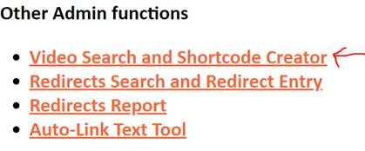

Click “Video Search and Shortcode Creator”, search for a video, select the video, and then scroll down to the bottom where it says “Short Code for embedding in compass”. The shortcodes listed are for that specific video. Simply copy and paste the appropriate code into the story of the Compass article.

Example:

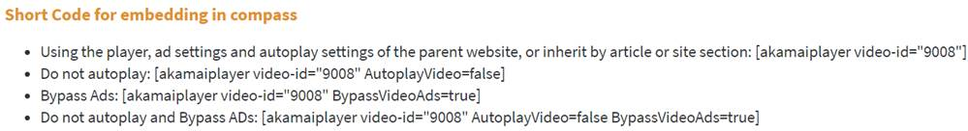

### Video Iframe Codes:

/video_iframe.aspx?vid={12345}&autoplay={true/false}&ad-tag-video-id={12345}

optional:  
autoplay - defaults to true  
ad-tag-video-id - gets video ad related to video, then on show item, then on homepage, then website.

Example iframe code to embed:

<div class="wrapper">

<div class="full-video"><iframe width="100%" border="0" src="/video_iframe.aspx?vid=371562&amp;autoplay=true"></iframe></div>

</div>

## YouTube Embed Code:

Embedding YT videos is something we can do on a very limited basis. If needed, use this code to embed a YouTube video:

<div class="frame-video"><iframe title="YouTube video player" src="https://www.youtube.com/embed/(YouTube Video ID)" frameborder="0" allowfullscreen=""></iframe></div>

Replace “(YouTube Video ID)” with the YouTube video ID.

In the Article item, be sure to click off the popout video player.

# Homepage Updates

## Homepage Related Videos

Each magazine homepage item in Compass has **3 places to relate video**:

* **Related TV video** 
  + This is the video that plays on the homepage, in the large video player on the bottom of the screen. When the video player is out of view, it will pop out and display on the bottom right of the screen on desktop.
  + Just need 1 video
* **Related article_video_playlist** 
  + These are the video that are printed at the end of an article.
  + We pull the entire list and randomize it then select 2 videos
  + It would be best to have 10-20 videos
* **Related watch_next_video_playlist**
  + These are the videos that appear after a user watches the complete (related tv) video and we show “watch next” in the player
  + We pull the entire list and randomize it then select 2 videos
  + It would be best to have 10-20 videos (originally we related 3 videos, now dev recommends 10-20)

Getting the number closer to 20 in the two playlists will make it less likely the user will see the same video in more than one place.

## Homepage Related Articles

Recommended and trending articles display below the last story on editorial detail pages. The dev team is working with Liftigniter to populate these new features with machine learning recommendations, but for now, we need to help populate the content.

The two areas we need to populate (and keep updated) for each site are under the MagazineHomePage items in Compass:

* **Related Recommended _Articles** – Need about 20 related per site. The code will pull 3 random at the bottom of the article from this list.
* **Related Trending_Articles** - Need about 20 per site. The code will pull 3 random articles from the list and display them at the bottom of the article. To quickly find the 20 most popular articles in google analytics, follow this method: go to GA > Behavior > site content > allpages > Filter by editorial. Select to return 25 rows and then copy the 25 rows and paste into a text editor. Then open the magazine hp in Compass, click add related trending articles, and paste each id into the search field and relate it.

## Featuring an Article on the Homepage

There can only be three featured articles on the HP. Articles listed under “LATEST” (below featured articles) will automatically populate the most recent content.

1. Select **MagazineHomePage**
2. **Edit** the homepage item for the correct site. Ex. Handguns - Homepage
3. Relate article under **Related Featured_Articles**
4. **Submit**.

# Listing Page Updates

## Featuring an Article on Top of a Listing Page

Only one article can be featured on the top of a listing page at a time. Note that the articles below the featured article are listed by publish date, so the featured article may appear duplicated on the page if it was recently published. Only main listing pages (e.g. Gear, Learn) can have a featured article. We cannot feature an article on sub listing pages (e.g. Gear - Rods, Learn - How-To).

1. Select **Pages – ListingPage.**
2. **Edit** the listing page item. Ex. Bowhunter - Recipes (Id 153185)
3. Relate article under **Related Articles**.
4. **Submit**.

Example of what a featured article on a listing page looks like:

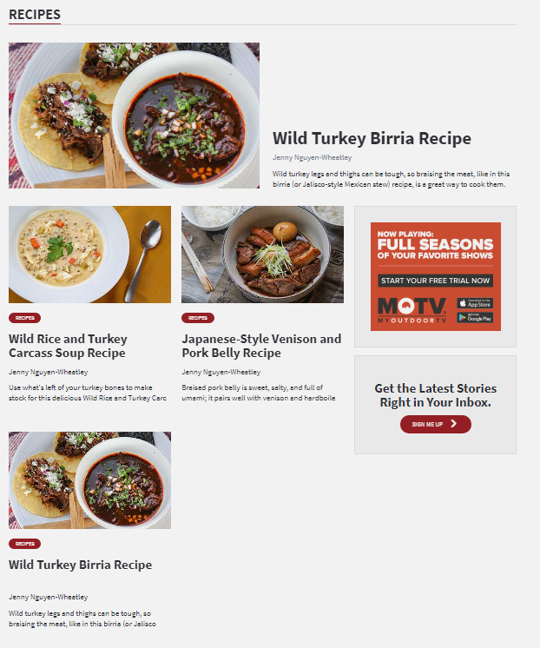

# How to add a Redirect

Be careful not to create a duplicate redirect. We are unable to delete them. If you need an entry deleted, the dev team will need to remove it. We can; however, edit existing redirects as needed.

If you need to edit a redirect, search for the redirect and click “Edit” on the far right.

Example:

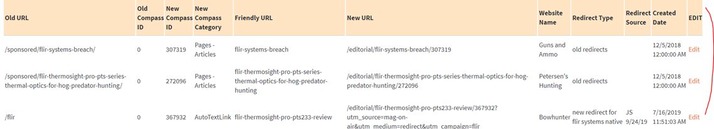

**Creating a new Redirect:**

1. Log in to Compass

2. Scroll down and click “Redirects Search and Redirect Entry”

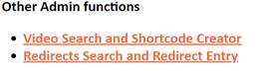

3. **SEARCH FOR REDIRECT**: use this to verify the redirect doesn’t already exist. For example, enter: /beretta

4. **ADD REDIRECT**: Fill in all info to create the redirect. (Example of redirect: <https://www.gunsandammo.com/beretta> (oldurl) > <https://www.gunsandammo.com/editorial/new-2019-beretta-apx-carry/360563> (newurl); Think of the Old URL as the URL FROM and New URL as TO).

**-oldurl:** Enter the URL you want redirected. Do not enter "http://", "https://", or any domain. Preferably start with a "/". Example: /berretta  
**-newtemplate:** Select template from dropdown. For articles, select “editorial”  
**-newcompassid:** Enter the compass id the old URL will redirect to. CANNOT be blank or 0.  
**-newcompasscategory:** Select from the dropdown. For articles, select “Pages - Articles”  
**-orig_id:** If the content was in a previous website version and database and you know it, please enter it. If you do not know it you can enter 0.  
**-friendlyurl:** This is basically the title of the content with dashes in place of spaces. Do not include any other punctuation. All lowercase.   
**-newurl:** If the article should be redirected to a page within the same website, DO NOT enter "http://", "https://", or any domain. If the old URL should redirect to a different website, enter the full path with https://{domain.com}. If you have no idea, go to a page that is like the one you are trying to redirect to and see how the URL is formatted. Example: /editorial/new-2019-beretta-apx-carry/360563  
**-websiteid:** Select from the dropdown the website that the old content came from. For example, an article that came from the old Outdoor Channel site would redirect to Game and Fish or Guns and Ammo but you would select "Outdoor Channel" from the dropdown.  
**-redirect_type:** Free-form text. Please type in something meaningful. Examples: old redirects, new redirect, 301

**-redirect_source:** Free-form text. Please type in something like who made the request and your name and date added.

5. Once you have entered all info, verify everything is entered correctly. Remember, you will not be able to edit the info after the redirect is created.

1. If everything looks good, click “Add Redirect”. Example of redirect entry below.

Redirect”. Example of redirect entry below.

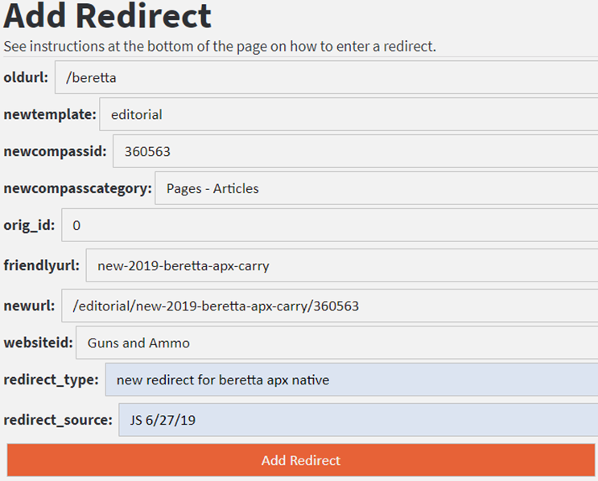

# How to create a “War Mode” promo

In Compass, a “War Mode” promo item is used to add an alert like “Don’t Miss” or “Breaking News” to the top of a magazine homepage.

Example of what a War Mode promo looks like:



**Step 1: Create War Mode Promo item**

1. Edit **Website Structure - Promo**.

2. Click **Add** (or select an existing War Mode promo item and **Duplicate** it. For example, see promo Id 331069 “Guns & Ammo - SHOT Show War Mode”).

3. Select **Website**.

4. Enter **CMS Name**, **CMS Description** and **Keywords**.

5. **Display Name / Headline** - Enter alert text. Example: DON’T MISS

6. **Page title** - Enter promo copy. Example: SHOT Show: See all the new shooting gear for 2019

7. **Link Text** - Enter call to action (Ex. Learn More)

8. **URL Link to item** - Enter promo link (Ex. <http://www.gunsandammo.com/show/shot-show/330947>)

9. **Is_Active** - Check to activate promo item.

10. Enter **StartPublishDate** and **EndPublishDate**. Note: The promo will not go live until it is related to the website’s homepage item.

11. Click **Submit**.

**Step 2: Add War Mode Promo to HP**

1. When you’re ready to add War Mode to a homepage, edit the site’s **MagazineHomePage** item.

2. Relate the promo item under **Related WarMode**.

3. Click **Submit**.

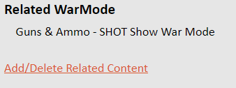

# Event Pages (SHOT Show, ATA Show, ICAST)

## SHOT Show

SHOT Show landing page URLs:

<http://www.gunsandammo.com/show/shot-show/330947>

<http://www.petersenshunting.com/show/shot-show/330960>

<http://www.gameandfishmag.com/show/shot-show/331064>

Assign the “SHOT Show” content type to articles you want listed on the pages.

Example:

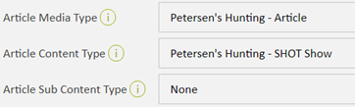

To add/remove videos, edit the “Show” item in Compass. Scroll down to “Related Videos” and click “Add/Delete Related Content”.

These are the show items to edit for the SHOT Show landing pages:

cid:image006.png@01D4AE4B.597706E0

## Creating a Photo Gallery

1. Resize each photo to 770x513. Keep image file sizes under 150kb.

1. Upload images to the FTP under the correct site folder.
2. In Compass, create a “Media - Photo” item for each photo. Enter the same info you do when creating an article hero photo, except a thumbnail image is not needed. Leave the “Small Thumbnail Image URL” field blank.
3. Create one “Media - Gallery” item. (Example Gallery: id 372730)

How to create a gallery:

1. Edit **Media - Gallery**
2. Click **Add**
3. **Website** – select website
4. **CMS Name, Display Name / Headline**, **Meta Page title**, **Link Headline** – enter title of photo gallery
5. **CMS Description**, **Meta Description** – enter gallery teaser/description
6. **Keywords** – enter title of gallery and any applicable keywords
7. **Is_Active** – check box to activate gallery
8. **StartPublishDate** – enter start date
9. **EndPublishDate**– enter end date (If you don’t want the gallery to expire, enter something like 12/1/2100)
10. Click **Submit**.
11. Select and edit gallery item again, this time to add related photos.
12. Scroll down to **Related Gallery_Photos**and relate each photo you want in the gallery. Photos will display in the order related.
13. Click **Submit**.

1. Relate the gallery to an article.

**Option 1** – Embed gallery somewhere in an article.

1. Edit **Pages - Articles**
2. Edit article item you want to embed the gallery into.
3. In the **Story** field, enter this in the html where you want the gallery to appear: [[gallery]]
4. Scroll down to **Related Photo_Galleries** and relate the gallery item.
5. Click **Submit**.

**Option 2** – Create a multi-page gallery.

1. Edit **Pages - Articles**
2. Edit article item.
3. Select “Gallery” for **Article Media Type.** (Example “Game & Fish - Gallery")
4. Scroll down to **Related Photo_Galleries** and relate the gallery item.
5. Click **Submit**.

## Common HTML

**Paragraph Tags**

<p>XXX</p>

**Break Tags**

The <br> tag inserts a single line break. Use it to enter line breaks, not to separate paragraphs.

<br/>

The clear attribute ensures the line break "clears" floated or aligned elements above them.

<br clear="all"/>

**Section Header Tags**

Use h3 header tags to separate paragraphs and sections. Don’t use h1 or h2 headers in an article story.

<h3>XXX</h3>

**Header Tags/Blockquote/Strong**

<h1>h1 header tag</h1>  
<h2>h2 header tag</h2>  
<h3>h3 header tag</h3>  
<h4>h4 header tag</h4>  
<h5>h5 header tag</h5>  
<h6>h6 header tag</h6>  
<blockquote>block quote</blockquote>  
<p><strong>bold</strong></p>

**Internal URL Link**

<a href="XXX">XXX</a>

Opens link in same window.

Example:

<a href="/community/post/7-more-fishing-hacks">7 More Fishing Hacks You Should Know</a>

**External URL Link**

<a href="XXX" target="_blank">XXX</a>

Opens link in new tab.

Example:

<a href="<http://www.outdoorhub.com/stories/2016/03/28/five-benefits-mineral-licks-know/>" target="_blank">benefits of mineral licks</a>

**Email Link**

<a href="<mailto:XXX>">XXX</a>

Example:

<a href="<mailto:jessyca.sortillon@OutdoorSG.com>">[jessyca.sortillon@OutdoorSG.com</a](mailto:jessyca.sortillon@OutdoorSG.com%3c/a)>

**Inline Photo (770x513)**

<figure class="story-image no-margin-top no-margin-bottom">

<img src="//content.osgnetworks.tv/gameandfishing/content/photos/XXX" alt="XXX" width="770" />

</figure>

**Inline Photo with Caption (770x513)**

<figure class="story-image no-margin-top no-margin-bottom">

<img src="//content.osgnetworks.tv/gameandfishing/content/photos/XXX" alt="XXX" width="770" />

<figcaption>XXX</figcaption>

</figure>

**Dynamic Gallery Shortcode**

<div id="dynamic_gallery"></div>

**Insert Related Gallery Shortcode**

[[gallery]]

**Shortcodes to Move Ad Placements in Articles**

If you need to move ads in a new article (or when reworking an older article), you can use the shortcodes below. Simply embed the appropriate shortcode in the html of the story where you want the ad to display.

[teads]  
[revealad]   
[adpos_rightC]

[adpos_rightD]

**Comment Out HTML**

Use this to hide or “comment out” text or images from a page.

<!--XXX-->

**Button without Caret**

For a standard button without the caret, you can use the class “btn” to add the rounded corner and background color.

<p><a href="Link" class="btn">Button Text</a></p>

**Button with Caret**

If you want the caret in it as well, you’d add a span with class icon-arrow-right inside the text area.

<p><a href="Link" class="btn">Button Text <span class="icon-arrow-right"></span></a></p>