# Magazine eNewsletter

A new newsletter info type in compass to hold the magazine newsletter details for this new layout.

* https://compass.osgnetworks.tv/magazinenewsletter.aspx?id={network newsletter compass ID}

Comp can be found here for a visual markup of the newsletter.

* https://video-dev.osgnetwork.com/comps/magazine/newsletter/email.html

Here’s the plan for how it will work in Compass.

* Compass Articles will be used by relating the articles that already exists in compass. If the article doesn’t exist, then it will need to be created. Contact the editorial team to have them create the article needed for the newsletter (Darren Choate and Jessyca Sortillon). A minimum number of articles is 4 for the layout.
* Ads can be related in order, always in the same position set out below. Maximum Ads that will be printed in the newsletter is 2. These are required to be related.
* You May Also Like article is optional to be related. This can be from any other site. If one is not related, then you will also not relate a “Get Emails From” promo to the newsletter. Thus, those sections in the newsletter will not be printed.
* Promos will need to be create for the Subscribe, Social and Get Emails From sections of the newsletter. The Get Emails From Promo should be from the “You May Also Like” article’s website. E.G. If you relate a Firearms News article in the “Related You May Also Like Articles” on the newsletter then the “Get Email From” Promo should be Firearms News link related to the newsletter. The Subscribe Promo and the Social Connect With Us Promo are required for the newsletter and must be related in that respective order. The “Get Email From” promo will not be displayed if it is not related as it is optional.

We will print out:

1. Subscribe to the Magazine CTA
2. Header
3. In this edition & date
4. Newsletter Synopsis
5. Related Article 1
6. Ad 1
7. Related Article 2
8. Related Article 3
9. Subscribe Promo
10. Ad 2
11. Related Article 4
12. Related Article 5-1000
13. Social Connect With Us On Promo
14. {optional You May Also Like section header} – this will be printed if there is an article related to the newsletter in the “Related You May Also Like Article”.
15. {optional Get Emails From Promo} – You do not have to have a “You May Also Like” Article related to the newsletter for this promo to be printed. This promo will be printed if you have it related to the newsletter.
16. {optional Bottom Promo} – fields on the compass newsletter. If the fields are completed, then this section will be printed in the newsletter. If those fields are empty, the section will not be printed.
17. Footer from Compass

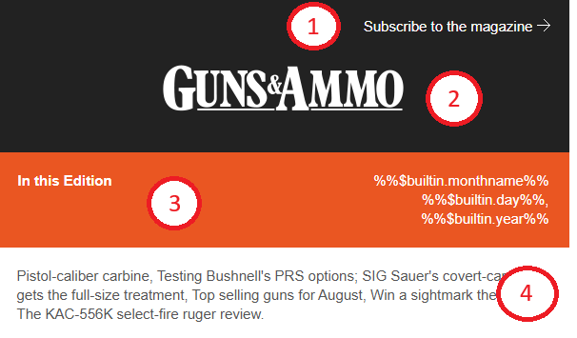

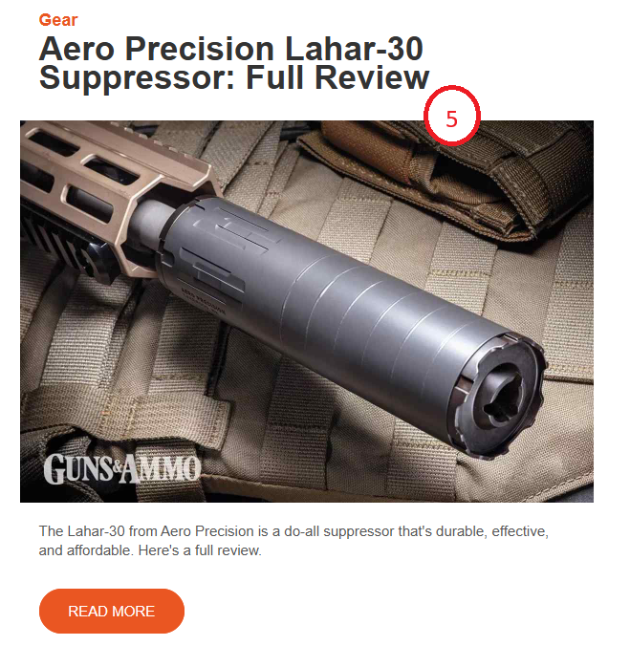

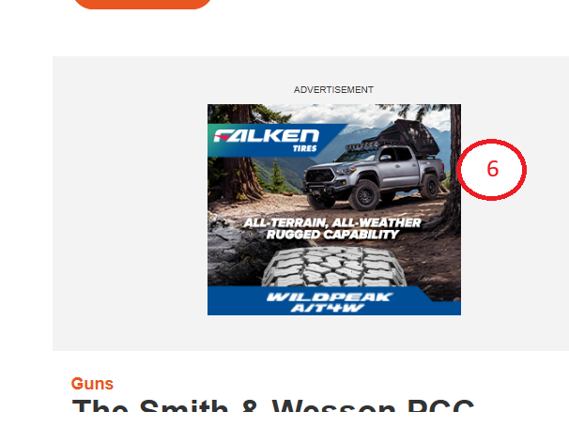

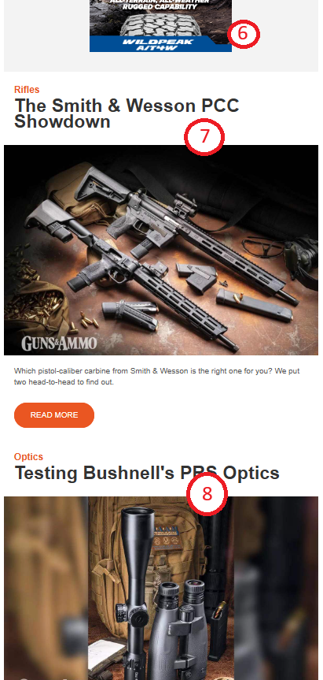

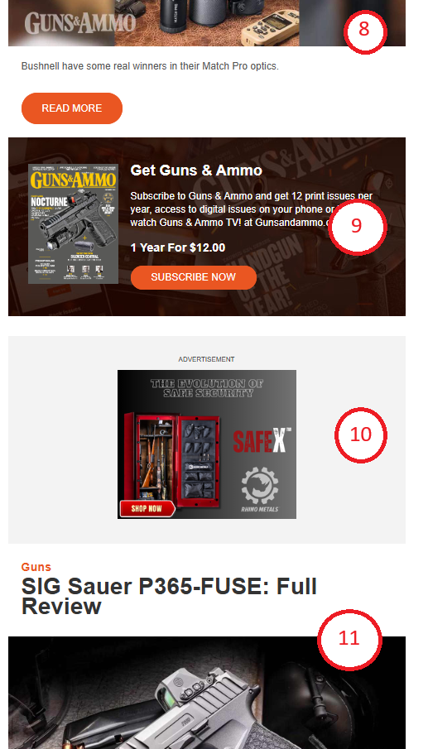

11. An Optional Section Header will print here if the section header is different from the previous section header (displayed #9) is different that the section header selected on the Newsletter Item #10.

If the #12 Newsletter item has the same section header as Newsletter item #10 then the section header will not print as shown here.

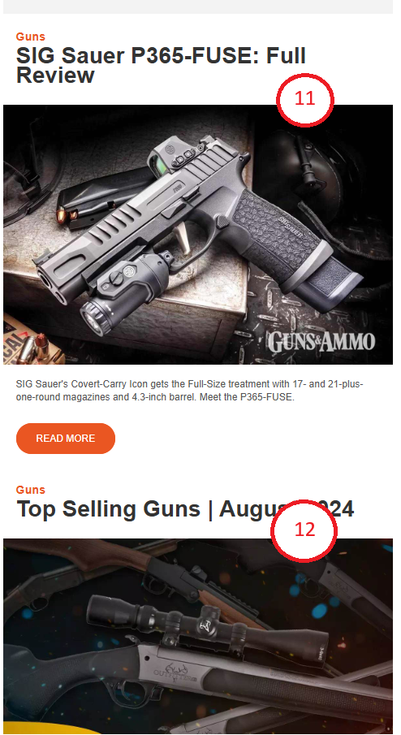

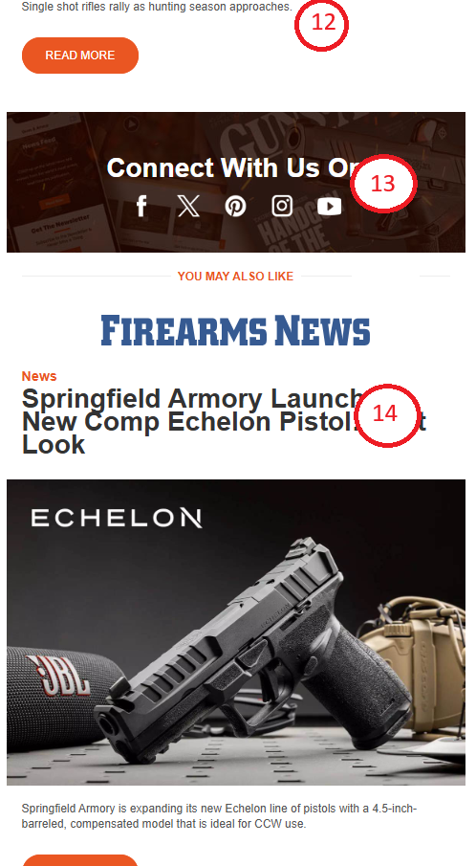

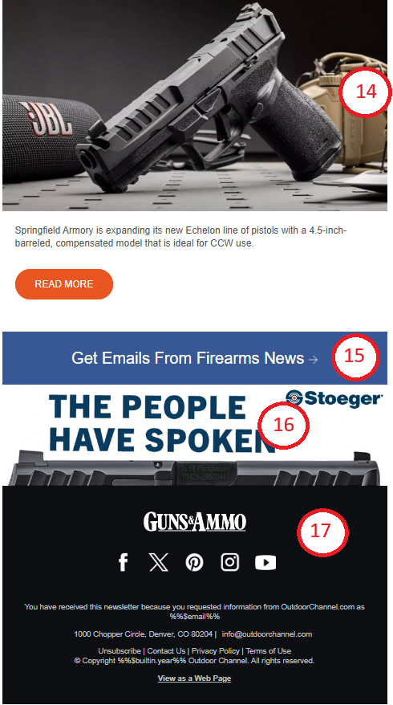

## CMS

Magazine Newsletters are located in the main Compass for network and magazine sites. The Magazine Newsletter is composed of related items from **Website Structure – AdTagsDisplay, Articles, Website Structure – Promos.A screenshot of a computer
**

### Magazine Newsletter

|  |  |  |
| --- | --- | --- |
| **Compass Field** | **Description** | **Example** |
| *Website | Website of the newsletter | Guns and Ammo, Game & Fish, In-Fisherman, Fly Fisherman, Shooting Times, Rifle Shooter, Wild Fowl, etc |
| *CMS Name | Title of the compass item | “GA NL - August 27, 2024 Newsletter” – Free form to enter whatever you wish |
| *Keywords | Information that will assist you to find/search for this compass entry | “Guns and Ammo - GA NL - August 27, 2024 Newsletter” – Free form to enter whatever you wish that will aid you in finding this compass entry |
| *Newsletter Title | Title of the newsletter that will be used as the Page Title in the newsletter HTML | “GA NL - August 27, 2024 Newsletter” – Free form to enter whatever you wish |
| Newsletter Synopsis | A highlight of what is in the newsletter. | “Pistol-caliber carbine, Testing Bushnell's PRS options; SIG Sauer's covert-carry icon gets the full-size treatment, Top selling guns for August, Win a sightmark thermal; The KAC-556K select-fire ruger review.”  If not completed it will not be printed in the newsletter. |
| *Website Logo Src | The url path for the website’s logo | “https://media.whatcounts.com/winnercomm_Outdoor/2024_temp/OC_Email_30yrFooterLogo_darkbgrd.png” |
| Bottom Promo URL | The url for the bottom promo that will take the user to when they click the image. | <https://www.handgunsmag.com/editorial/stoeger-str9mc-pistol/493542>  Optional. If not completed the promo area will not be displayed. |
| Bottom Promo Image Src | The url of the image that will be displayed at the bottom promo. | <https://media.whatcounts.com/winnercomm_Outdoor/Ads/stoeger.jpg>  Optional. If not completed the promo area will not be displayed. |
| *CSS | The styles of the newsletter. | This field holds the styles for the network newsletter. BE VERY CAREFUL EDITING THIS FIELD. ONLY EDIT IF NECESSARY. |
| *Footer HTML | The footer HTML to display the footer logo, social links, etc | This field holds the HTML markup for the footer of the newsletter. BE VERY CAREFUL EDITING THIS FIELD. ONLY EDIT IF NECESSARY. |
| *Header HTML | The header HTML to display the header logo and newsletter date | This field holds the HTML markup for the header of the newsletter. BE VERY CAREFUL EDITING THIS FIELD. ONLY EDIT IF NECESSARY.  The “Subscribe to the magazine” html and link is editable in the Header HTML field and must be the url to the newsletter’s website subs url. |

**Related Items:**

* Related Ads (Website Structure – AdTagsDisplay)
* Relate Articles (Pages – Articles)
* Related You May Also Like Articles (Pages – Articles)
* Related Subscribe, Social & Get Emails From Promos (Website Structure – Promos) – These related items MUST BE IN THE FOLLOWING ORDER:
  1. Subscribe
  2. Social
  3. Get Emails From
* Related Other Content Promos (Website Structure – Promos)

### Website Structure – AdTagsDisplay

For the Network Newsletter there are only 2 ad positions that are displayed within the newsletter and are always displayed in the same position in the newsletter.

|  |  |  |
| --- | --- | --- |
| **Compass Field** | **Description** | **Example** |
| Website | Dropdown select of the Website of the Newsletter | “Outdoor Channel” |
| CMS Name | Name of the Ad | “300x250 - TOP Ad - OC NL - Falken US24” |
| CMS Description | Name of the Ad and any other information. | “300x250 - TOP Ad - OC NL - Falken US24” |
| Keywords | Keywords to be able to search for this ad in compass | “300x250 - TOP Ad - OC NL - Falken US24” |
| Display Name / Headline | Name of the Ad | “300x250 - TOP Ad - OC NL - Falken US24” |
| AdType | Dropdown of Ad Types to select from. | Adpos_rightB |
| URL | URL where the user will be taken when they click the ad in the newsletter | “https://www.falkentire.com/wildpeak/at4w” |
| AdTag | The image of the ad that will be displayed in the newsletter | “https://media.whatcounts.com/winnercomm_Outdoor/Ads/Falken-Tires-300x250.jpg” |
| AdTag_DFP_Script | The image of the ad that will be displayed in the newsletter | “https://media.whatcounts.com/winnercomm_Outdoor/Ads/Falken-Tires-300x250.jpg” |

### Pages - Articles

The newsletter can contain multiple articles that should be from the Newsletter’s Website. The articles are displayed in the order that they are displayed in the “Related Articles” on the Magazine Newsletter compass entry. A minimum of 4 newsletter items should be used so that the 2 ad positions will be printed in the newsletter.

The Article must be active and have a Related Hero Photo that is also active. Active meaning that the “Is Active checkbox is checked and the current date or date of the newsletter to be sent is within the date range of the StartPublishDate and EndPublishDate. E.G.:

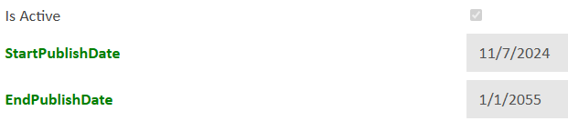

The fields used in the newsletter are as follows:

|  |  |  |
| --- | --- | --- |
| **Compass Field** | **Description** | **Example** |
| Website | Dropdown of all websites to choose from. Select the website that is associated with the newsletter item, not the name of the website of the newsletter. | “Guns and Ammo” – The article that is related should have the same website as the newsletter compass info type. E.G. If the newsletter is for Guns and Ammo then the website of the article should also be “Guns and Ammo”. |
| *Headline | Headline of the article/video | “Aero Precision Lahar-30 Suppressor: Full Review” |
| Teaser | Teaser of what the newsletter item to spark interest to click on the newsletter item. | “The Lahar-30 from Aero Precision is a do-all suppressor that's durable, effective, and affordable. Here's a full review.” |
| Article Media Type | The Article’s Media Type that indicates if the Article is a Regular Article or Video Article, Audio Article, or Gallery Article | The dropdown choices for this are Article, Video, Audio, Gallery. This will determine what the button text CTA should read. If the article is  Article = “READ MORE”  Video = “WATCH NOW”  Audio = “LISTEN NOW”  Gallery = “VIEW NOW” |
| Article Content Type / Article Sub Content Type / Article Sub Content Type Topics | The Article Content Type field or the Article Sub Content Type field if selected or the Article Sub Content Type Topic field if selected and not equal to “_None” | “Guns and Ammo – Gear” / “Guns and Ammo – Gear – Suppressors”  The article sub content type Topics field will be displayed if selected. If “_None” is selected, then the article sub content type will be used if selected. If “_None” is selected, then the article content type value will be used. |
| Related Hero Image | The 1st item in the Related Hero Image will be displayed | The Related Hero Image is a required field and must have an entry related. If not, entry is related then the article is considered inactive. See the “Related Hero Image / Media – Photo” section below for the fields that are used for the image in the newsletter. |

### Related Hero Image / Media - Photo

A Media – Photo item is related to the article in the “Related Hero Image”. In this compass item the following fields are used in the newsletter.

|  |  |  |
| --- | --- | --- |
| **Compass Field** | **Description** | **Example** |
| Newsletter Image URL | The image URL to an image that is the size of 1200x800 if a different image from the Hero Crop field on the photo compass item is needed for the newsletter. | https://content.osgnetworks.tv/photopacks/aero-precision-lahar-30-review_509619/509622_gaad-sup-aero-precision-lahar-30-03-1200x800_hero_1200x800.jpg |
| Hero Crop | The image URL to an image that is the size of 1200x800 for the article. | https://content.osgnetworks.tv/photopacks/aero-precision-lahar-30-review_509619/509620_gaad-sup-aero-precision-lahar-30-01-1200x800_hero_1200x800.jpg |

## Related Article Field Callouts

Article content type or Article Sub Content Type or Article Sub Content Type Topics

Related Hero Image compass entry’s Newsletter Image URL field if completed otherwise the Hero Crop field.

The Headline, Image and Button all use a generated URL to the article on the article’s website.

Will display “READ MORE” if the article’s Article Media Type field is “Article”. Will display “WATCH NOW” if the article’s Article Media Type is “Video”. Will display “LISTEN NOW if the article’s Article Media Type is “Audio”. Will display “VIEW NOW” if the article’s Article Media Type is “Gallery”.

Teaser

Displays “Sponsored” if there is a Sponsor Related to the article.

Headline

## Related Other Content Promos Field Callouts

The Promos are used for special items such as Listing Page, Shows, Videos, Podcasts, etc. Please use the Promo Type field on the Promo to indicate what the type of promo.

**For a Listing page**:

Link Text field of Promo

Image URL field of Promo

For the Alt Text, use the Time Text field of the Promo

Description field of Promo

Marker Text field of Promo

For the color of the button, use the Color field of the Promo

Display Name / Headline field of Promo

To indicate what position the Other Content item should be inserted, use the Style field of the Promo and the item will be inserted after it. E.G. If you put a 1 in the style field, the promo item will be inserted after the 1st positioned article.

<http://wcistagecompass.osgnetwork.com/admin/edit_program_info.asp?action=stories&type=110&id=517856&website_id=0>

Website Structure - Promo

For items that are sponsored, place any text in the “Page Title” field. To remove the “Sponsored” from the promo, type in a space in the “Page Title” field.

For placement of the promo in the newsletter, use the “Style” field of the promo.

E.G. In the example above the promo will be inserted after the 3rd article.

For the color of the category and CTA button, the newsletter will use the newsletter’s website color UNLESS you enter a color on the promo or the promo is a different website than the newsletter.

<https://compass.osgnetworks.tv/Admin/view_program_info.asp?action=stories&type=110&id=519161&website_id=0>

