# Network eNewsletter

A new newsletter info type in compass to hold the network newsletter details for this new layout.

* https://compass.osgnetworks.tv/networknewsletter.aspx?id={network newsletter compass ID}

Comp can be found here for a visual markup of the newsletter.

* https://video-dev.osgnetwork.com/comps/network/newsletter/networknewsletterEmail.html

Here’s the plan for how it will work in Compass.

* All “sections” will be newsletter items in compass and order can be set by related items.
* Ads can be related in order, always in the same position set out below.
* Section headers will be a new compass item that will be related as needed to the newsletter items.
* NO PROMOS WILL BE USED

We will print out:

1. Header
2. In this edition
3. Newsletter Synopsis
4. {optional header}
5. Related newsletter item 1
6. Ad 1
7. {optional header} – will only print if different value than the previous optional header
8. Related newsletter item 2
9. {optional header} – will only print if different value than the previous optional header
10. Related newsletter item 3
11. {optional header} – will only print if different value than the previous optional header
12. Related newsletter item 4
13. Ad 2
14. {optional header} – will only print if different value than the previous optional header
15. Related newsletter item 5-1000
16. Marketing promo or nothing
17. Footer from Compass

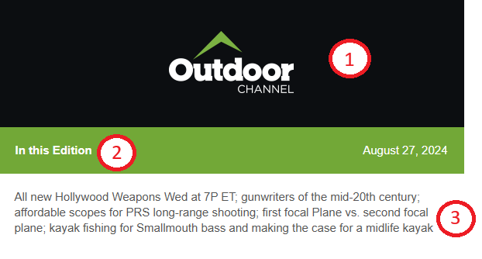

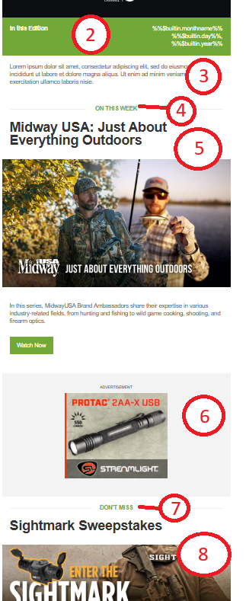

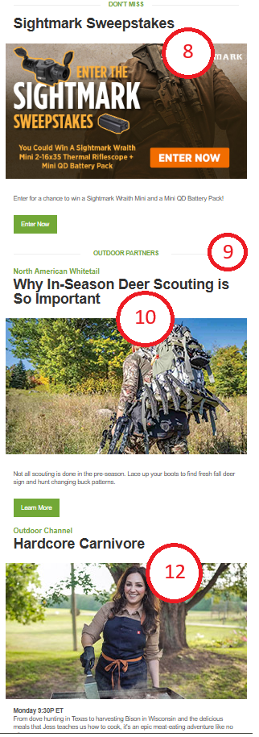

11. An Optional Section Header will print here if the section header is different from the previous section header (displayed #9) is different that the section header selected on the Newsletter Item #10.

If the #12 Newsletter item has the same section header as Newsletter item #10 then the section header will not print as shown here.

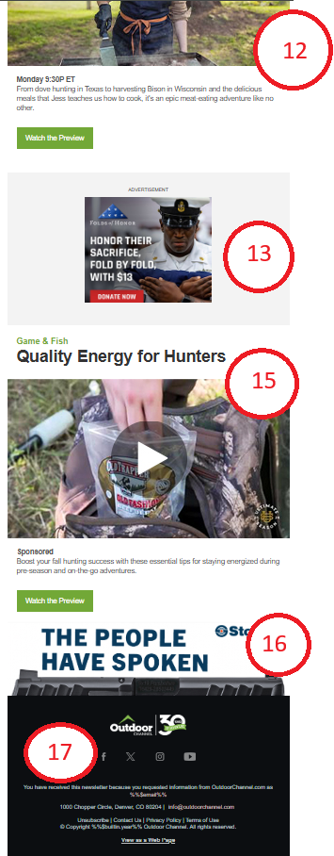

14. An Optional Section Header will print here if the section header is different from the previous section header (displayed #12) is different that the section header selected on the Newsletter Item #15.

If the #15 Newsletter item has the same section header as Newsletter item #12 then the section header will not print as shown here.

## CMS

Network Newsletters are located in the main Compass for network and magazine sites. They Network Newsletter is composed of a **Network Newsletter** info type with related items from **Newsletter Items** and **Website Structure – AdTagsDisplay**.

### Network Newsletter

|  |  |  |
| --- | --- | --- |
| **Compass Field** | **Description** | **Example** |
| *Website | Website of the newsletter | Outdoor Channel, Sportsman Channel, WFN |
| *CMS Name | Title of the compass item | “OC Newsletter - 10/22/2024 - I1014 - Why In-Season Deer Scouting is So Important” |
| *Keywords | Information that will assist you to find/search for this compass entry | “Outdoor Channel - OC Newsletter - 10/22/2024 - I1014 - Why In-Season Deer Scouting is So Important” |
| *Newsletter Title | Title of the newsletter that will be used as the Page Title in the newsletter HTML | “Why In-Season Deer Scouting is So Important” |
| Newsletter Synopsis | A highlight of what is in the newsletter. | “Pistol-caliber carbine, Testing Bushnell's PRS options; SIG Sauer's covert-carry icon gets the full-size treatment, Top selling guns for August, Win a sightmark thermal; The KAC-556K select-fire ruger review.”  If not completed it will not be printed in the newsletter. |
| *Website Logo Src | The url path for the website’s logo | “https://media.whatcounts.com/winnercomm_Outdoor/2024_temp/OC_Email_30yrFooterLogo_darkbgrd.png” |
| Bottom Promo URL | The url for the bottom promo that will take the user to when they click the image. | <https://www.handgunsmag.com/editorial/stoeger-str9mc-pistol/493542>  Optional. If not completed the promo area will not be displayed. |
| Bottom Promo Image Src | The url of the image that will be displayed at the bottom promo. | <https://media.whatcounts.com/winnercomm_Outdoor/Ads/stoeger.jpg>  Optional. If not completed the promo area will not be displayed. |
| *CSS | The styles of the newsletter. | This field holds the styles for the network newsletter. BE VERY CAREFUL EDITING THIS FIELD. ONLY EDIT IF NECESSARY. |
| *Footer HTML | The footer HTML to display the footer logo, social links, etc | This field holds the HTML markup for the footer of the newsletter. BE VERY CAREFUL EDITING THIS FIELD. ONLY EDIT IF NECESSARY. |
| *Header HTML | The header HTML to display the header logo and newsletter date | This field holds the HTML markup for the header of the newsletter. BE VERY CAREFUL EDITING THIS FIELD. ONLY EDIT IF NECESSARY. |

**Related Items:**

* Related Ads (Website Structure – AdTagsDisplay)
* Relate Network_NewsletterItems (Network NewsletterItems)
  + When relating the created newsletter items:
    1. Click on "Add/Delete Related content" link
    2. In related Modal
       1. Change the "Filter by Website" to be the website of the NNI you just entered.
       2. Click "Load" button and you will see your NNI in the top box

### Website Structure – AdTagsDisplay

For the Network Newsletter there are only 2 ad positions that are displayed within the newsletter and are always displayed in the same position in the newsletter.

|  |  |  |
| --- | --- | --- |
| **Compass Field** | **Description** | **Example** |
| Website | Dropdown select of the Website of the Newsletter | “Outdoor Channel” |
| CMS Name | Name of the Ad | “300x250 - TOP Ad - OC NL - Falken US24” |
| CMS Description | Name of the Ad and any other information. | “300x250 - TOP Ad - OC NL - Falken US24” |
| Keywords | Keywords to be able to search for this ad in compass | “300x250 - TOP Ad - OC NL - Falken US24” |
| Display Name / Headline | Name of the Ad | “300x250 - TOP Ad - OC NL - Falken US24” |
| AdType | Dropdown of Ad Types to select from. | Adpos_rightB |
| URL | URL where the user will be taken when they click the ad in the newsletter | “https://www.falkentire.com/wildpeak/at4w” |
| AdTag | The image of the ad that will be displayed in the newsletter | “https://media.whatcounts.com/winnercomm_Outdoor/Ads/Falken-Tires-300x250.jpg” |
| AdTag_DFP_Script | The image of the ad that will be displayed in the newsletter | “https://media.whatcounts.com/winnercomm_Outdoor/Ads/Falken-Tires-300x250.jpg” |

### Network NewsletterItems

The newsletter can contain multiple newsletter items from all OSG properties. The newsletter items are displayed in the order that they are displayed in the “Related Network_NewsletterItems” on the Network Newsletter compass entry. A minimum of 4 newsletter items should be used so that the 2 ad positions will be printed in the newsletter.

Network Newsletter Items can be displayed under section headers. These headers are customizable and are optional in the newsletter.

1. When relating the created newsletter items:
   1. Click on "Add/Delete Related content" link
   2. In related Modal
      1. Change the "Filter by Website" to be the website of the NNI you just entered.
      2. Click "Load" button and you will see your NNI in the top box

|  |  |  |
| --- | --- | --- |
| **Compass Field** | **Description** | **Example** |
| Website | Dropdown of all websites to choose from. Select the website that is associated with the newsletter item, not the name of the website of the newsletter. | “North American Whitetail” |
| *CMS Name | Title of the newsletter item that is displayed when searching for a newsletter item in compass. | “OC NL - 10/22/24 - I1014 - Story 1 - Why In-Season Deer Scouting is So Important” |
| *CMS Description | Description of the compass item and any other info that may be useful. | “OC NL - 10/22/24 - I1014 - Story 1 - Why In-Season Deer Scouting is So Important” |
| *Keywords | Information that will assist you to find/search for this compass entry | “Outdoor Channel - OC NL - 10/22/24 - I1014 - Story 1 - Why In-Season Deer Scouting is So Important” |
| *Headline | Headline of the article/video | “Why In-Season Deer Scouting is So Important” |
| Subheadline | Subheader of the article/video. This can also be a Date and Time of a show that may be on the channel or “Sponsor” for sponsored text. | “Sponsor”  “Monday 9:30P ET” |
| Section Header | A dropdown selection of the “Newsletter Section Headers” compass info type entries | “OUTDOOR PARTNERS”  “DON’T MISS”  “ON THIS WEEK”  **These are managed by creating them in the “Newsletter Section Headers” compass info types. These are not site specific and can be used for any network newsletters. |
| Teaser | Teaser of what the newsletter item to spark interest to click on the newsletter item. | “Not all scouting is done in the pre-season. Lace up your boots to find fresh fall deer sign and hunt changing buck patterns.” |
| Item Image Src | URL of the image shown in the newsletter for the item | “https://media.whatcounts.com/winnercomm_Outdoor/I1014/508316_comstock-in-season-scouting.jpg” |
| Description of Image for ADA | Description of the image. This is for ADA and should NOT be the image url or name of the newsletter item | “Hunter with large backpack walking through field.” |
| Item URL | URL of the item to where the user will be taken when they click on the item in the newsletter. | “https://www.northamericanwhitetail.com/editorial/in-season-deer-scouting/508306” |
| Button Image Src | The url of the image if the button should be an image and not just text. | <https://media.whatcounts.com/winnercomm_WFN/hdr-see-schedule.png> - used for an image for the schedule on WFN possibly. |
| Button Text | Text to be displayed on the CTA button | “Learn More”  “Watch the Preview”  “Read More” |

### Newsletter Section Headers

These are the headers above the sections in the Network Newsletter to separate out the types of newsletter items within the newsletter and group newsletter items together of like section headers.

|  |  |  |
| --- | --- | --- |
| **Compass Field** | **Description** | **Example** |
| Website | Website of the section header but can be left as “none” to be use across all network newsletters |  |
| CMS Name | Name of the section header | “On This Week” |
| CMS Description | Description of the section header | “On This Week for a show or episode that is being promoted” |
| Keywords | Keywords that help with searching for this section header in compass | “On This WeeK” |
| Section Headline | Title of the section in all caps | “ON THIS WEEK” |

## Newsletter Item Field Callouts

Section Header – This will print if different value from the previous Newsletter Item’s Section Header.



Website

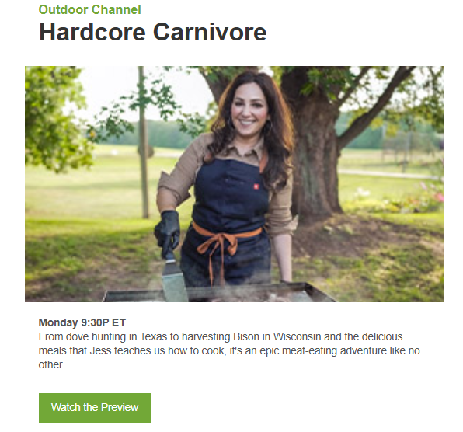

Teaser

Subheadline field. Also used for “Sponsored”

The Headline, Image and Button all use the Item URL field to take the user to the site.

On hover of the image should display the Description of Image for ADA field.

The button could be an image. For it to be an image you would use the Button Image Src field instead of the Button Text field.

Button Text

Item Image Src

Headline